Experiment No: 01
Name of the Experiment: Data Transmission using Frequency Division Multiplexing
Theory: Frequency Division Multiplexing (FDM) is a technique that allows multiple data signals to be transmitted simultaneously over a single communication channel by assigning each signal a unique carrier frequency. The process involves modulation, multiplexing, transmission, and subsequent demultiplexing and demodulation at the receiver end.
Block Diagram:
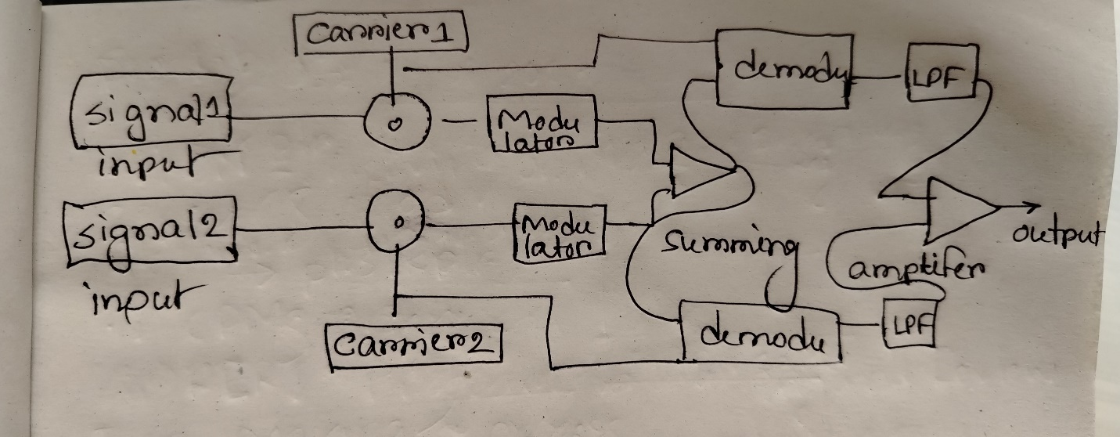
Explanation of the Diagram:
- Inputs (Signal 1 and Signal 2): These represent the two independent input signals that need to be transmitted simultaneously. Each signal contains information that needs to be transmitted over the communication channel.
- Carriers (Carrier 1 and Carrier 2): Each input signal is assigned a unique carrier frequency. Carrier frequencies are used to modulate the input signals, ensuring that the signals can coexist in the same channel without interference.
- Modulators: The modulators combine the input signal with its respective carrier frequency. This process shifts the frequency of the signal to a specific range determined by the carrier. Different modulation techniques like AM (Amplitude Modulation) or FM (Frequency Modulation) may be used.
- Summing: After modulation, the signals are combined (summed) to form a single composite signal. This composite signal contains all the modulated signals, each occupying a distinct frequency band.
- Transmission: The composite signal is transmitted over the communication channel to the receiver.
- Demodulation: At the receiver end, the signals are separated using demodulators tuned to the specific carrier frequencies. This process retrieves each individual signal from the composite signal.
- Low-Pass Filters (LPF): The demodulated signals are passed through low-pass filters to remove any high-frequency noise or artifacts introduced during modulation or transmission.
- Amplifier: The filtered signals are amplified to restore them to their original amplitude for further processing or use.
- Output: The final output consists of the original signals (Signal 1 and Signal 2) after they have been processed and demodulated.
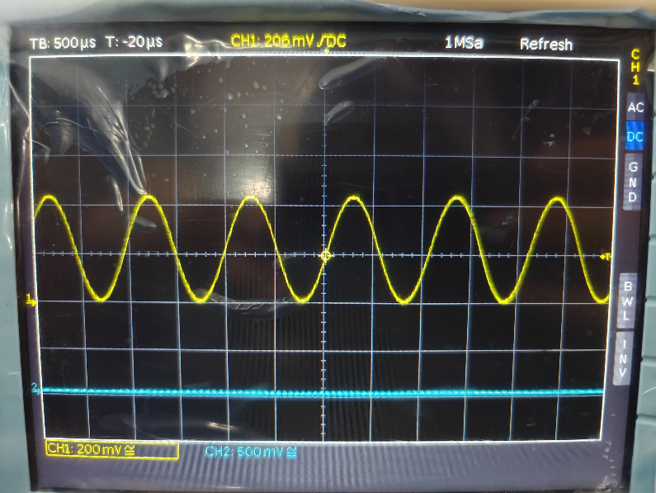
Input signal: Carrier:
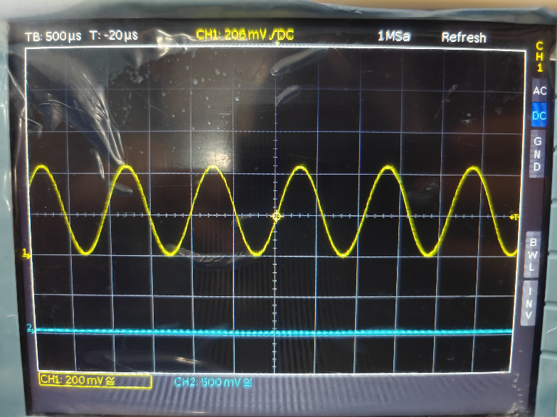
Output:
Modulated
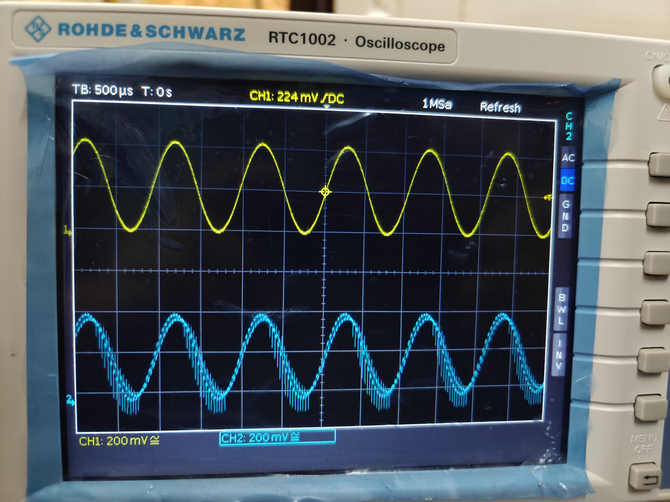

Summing:
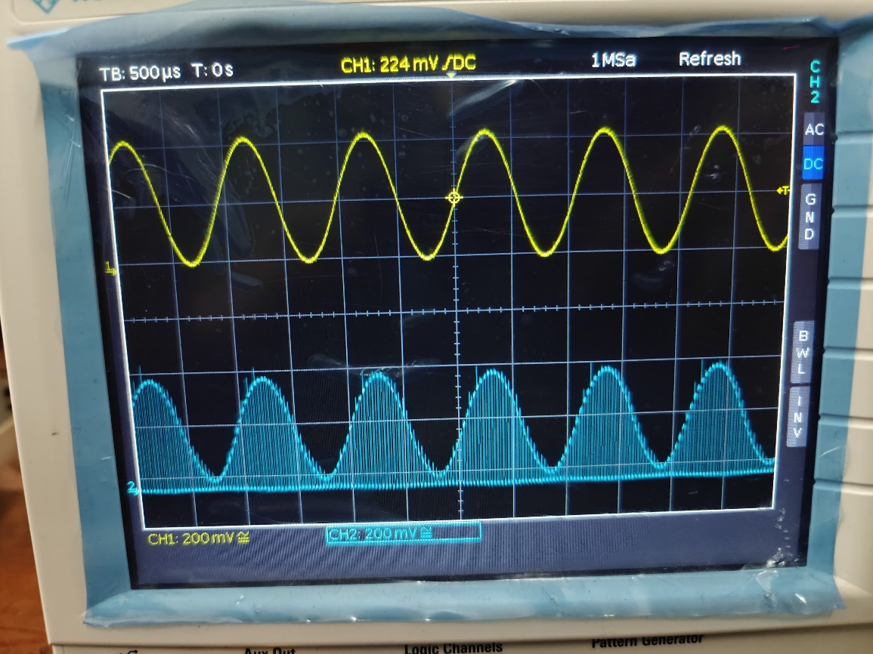
Demodulated:
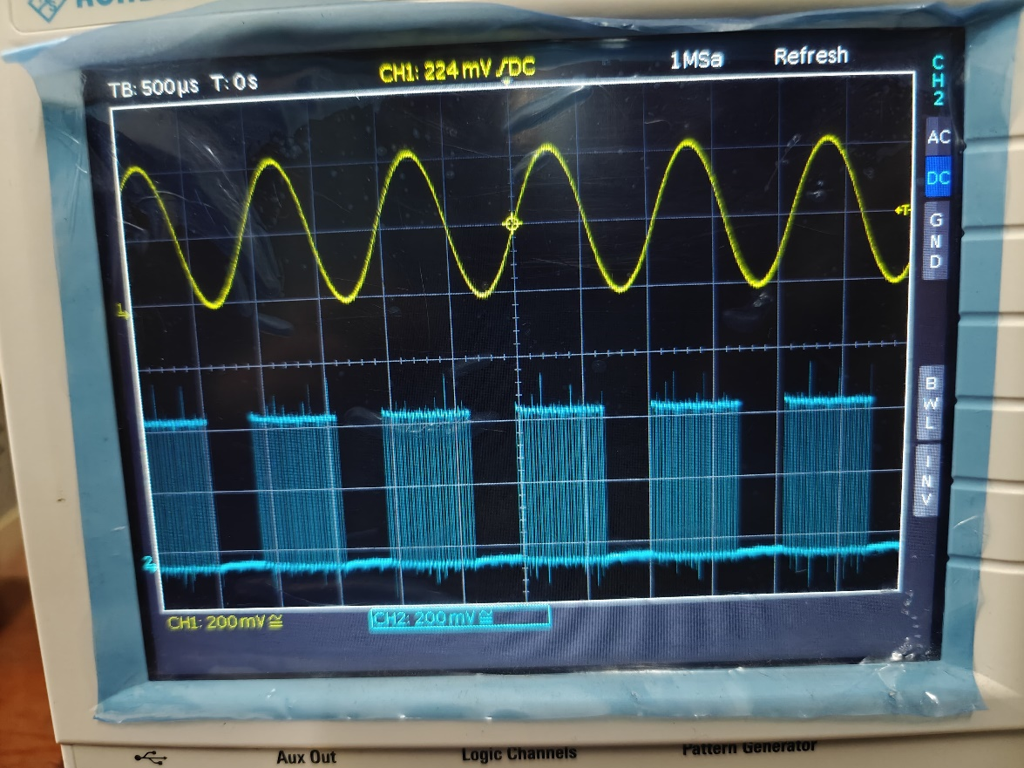
Low Pass Filter:
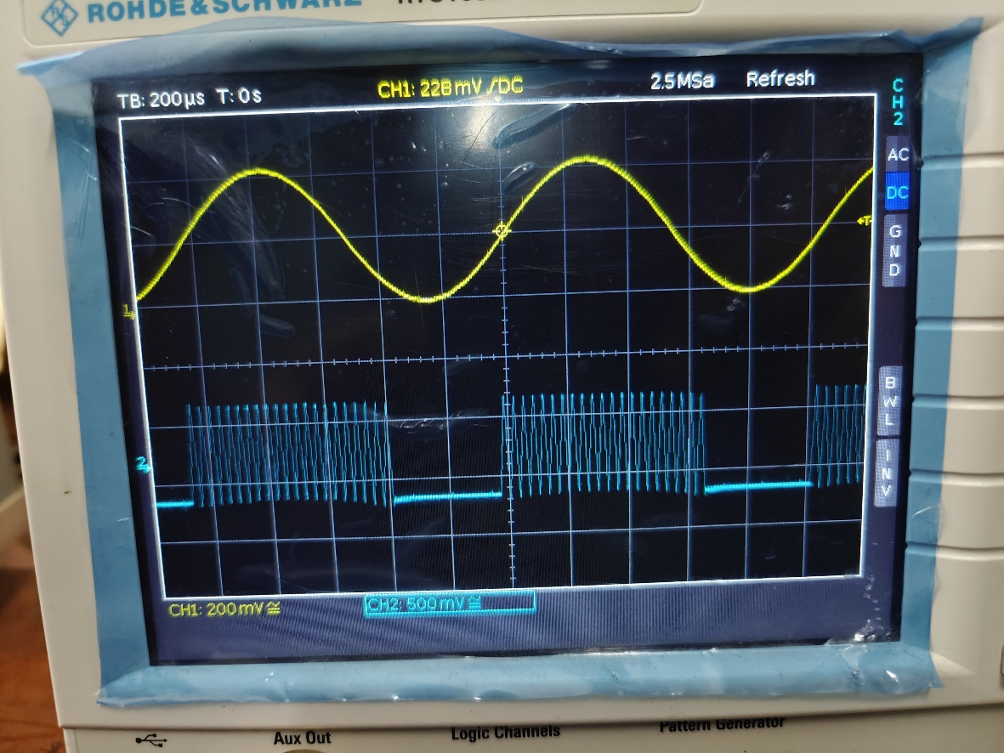
Amplified:
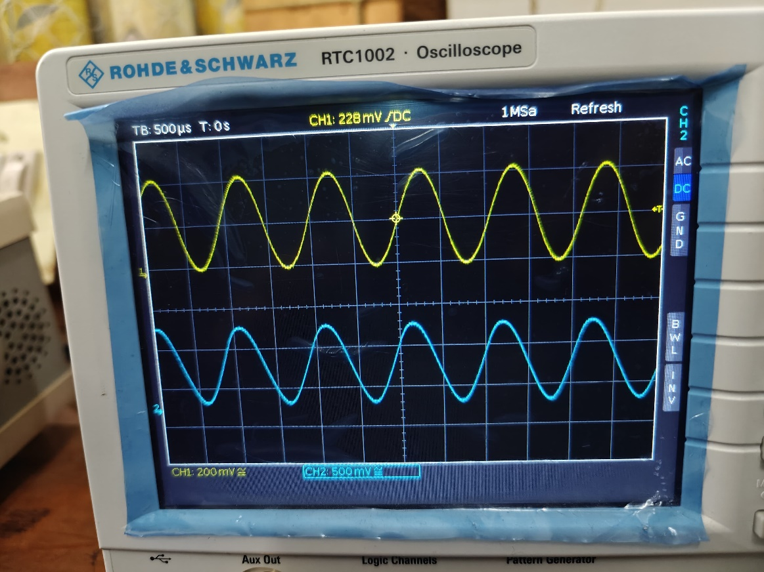
Discussion: The experiment demonstrates the practical implementation of Frequency Division Multiplexing (FDM), a technique that enables simultaneous transmission of multiple signals over a single channel by assigning unique carrier frequencies to each signal. This ensures efficient bandwidth utilization, as seen in radio and television broadcasting, DSL internet, and optical fiber communication. The oscilloscope visuals highlight how input signals are modulated, combined, and later separated at the receiver, emphasizing the importance of proper filtering, synchronization, and noise reduction using low-pass filters and amplifiers. FDM’s ability to isolate signals and reconstruct them without interference showcases its relevance in modern communication systems, where bandwidth efficiency and signal integrity are critical.

